The littering problem

You may have seen little bits of rubbish scattered around the place, this is the littering problem.

People who just throw rubbish out the window and don’t care to put it in the bin mostly make littering! Even if they do try to put it in the bin, sometimes they just throw it and probably miss.

And if you or anyone has thrown a piece of rubbish it’s probably been less than four to ten centimetres mainly because it doesn’t seem too bad like I mean it’s only a small piece of rubbish… well you’re wrong!! That tiny piece of rubbish most likely ended up on a beach or in the ocean and then it becomes someone else’s problem. Including the government because around seventy percent of plastic eventually sinks to the bottom of the sea.

Governments have different ways of dealing with the littering problem in their cities.
For example:
- Thailand has a heavy fine of around US$2000! And that’s a two with three zeros after it.
- Where as in Hong Kong every ten feet there is a bin.
- And in North Sydney Australia the government took all the bins away and somehow it worked!

Currently in Dubai the way I see that the Sheikh is handling litter is having lots of employees and volunteers working around the clock picking up rubbish.

Some governments are throwing rubbish into cracks between the tectonic plates.
When they dump the rubbish it’s in metal barrels, and if you are a sciencey personmost metals corrode and if the barrels have a radioactive material in them I mean
U92 and PU94 (uranium and plutonium) leak out it could kill a whole habitat!

Following up on the tectonic cracks if the barrels get caught in a lava or magma reserve a under water volcano could erupt the content, imagine an under water volcano erupting uranium!
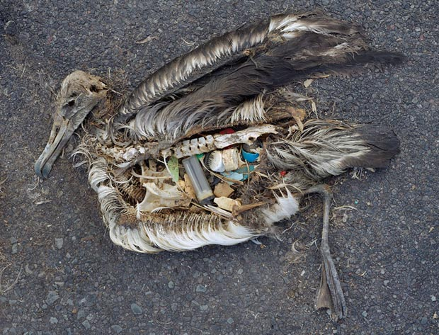
http://www.lifeoutofplastic.com/wp-content/uploads/2014/05/albatros.jpg

